**Drip Irrigation:**

**A Sustainable Solution for Efficient Water Management in Agriculture**

**Abstract:**

Traditional irrigation techniques are being replaced with drip irrigation, a highly efficient and environmentally friendly means of applying water in agriculture. With this method, water is slowly, steadily, and precisely delivered to plant roots, increasing water usage efficiency and reducing waste.The basic idea behind drip irrigation is the placement of emitters close to individual plants along a network of tubes or pipelines. These emitters allow water to be administered directly to the root zone by releasing water droplets or a thin stream. Field crops, orchards, vineyards and greenhouse farming are just a few of the agricultural practise where drip irrigation is used. This method has shown to be particularly successful in areas with erratic terrain, salty soils, or little water resources. By providing localized irrigation, drip systems enable farmers to optimize land use, increase crop productivity, and mitigate environmental impacts.

**Field of work:**

Out field of invention for drip irrigation primarily falls under the domain of agricultural engineering and irrigation technology. Drip irrigation involves the development and implementation of systems, methods, and components that efficiently deliver water and nutrients to plants at their root zone. The invention and advancements in drip irrigation have been driven by the need for sustainable agricultural practices, water conservation, and increasing global food demand. With the help of intelligence, the processes is automated.

**Background Work:**

The present invention relates to irrigation systems specifically adapted for the surface or subsurface watering of long runs of crops, whether on greenhouse benches or in the field. More specifically, the present invention relates to a trickle irrigation system wherein the water is allowed to discharge slowly, directly at the desired point of application, typically about the base of the plants. US patent number US20080196303A1 describes a system that is used for watering the mushrooms using drip irrigation mechanism. Various parameters of soil were taken into considerations for the watering the mushroom plants. The system involves inserting a long, high-pressure tube into a layer of mushroom growing medium on a frame.

**Description of the system:**

The developed system was developed with DHT11 (temperature and humidity), tensiometer (soil moisture), potentiometer (pH sensor), BH1750 (sunlight intensity sensor), ultrasonic sensor(liquid level sensor) sensors and hardware including Raspberry pi, ESP32/Node MCU, relays and solenoid valve.

The Raspberry pi is used as the server where the Node-Red will be running continuously and the making decisions on the data received from the various sensors though ESP32/Node MCU by MQTT protocol. The temperature, humidity sensors and sunlight sensor were deployed centrally at the server it self. The sunlight sensor is responsible for switching the insecticides light when it is dark at the night.

A centralized tank is responsible for storing water along with the fertilizers primarily alongside with pesticides. This is integrated with pH sensor, ultrasonic liquid level sensor along with a camera. The pH sensor is responsible for the conforming wherever any fertilizer or pesticide is mixed in it. With the ultrasonic liquid level sensor the water in the tank is monitored and it will be switching the motor as well. The output of this tank is integrated with a master solenoid valve. A water mixer is integrated inside the water tank and will be controlled automatically whenever any fertilizer or pesticide is mixes in the tank.

The soil moisture sensor will the primary data for the switching the solenoid valve whenever the sensed data crosses the threshold value. The pH sensor in the soil will be responsible for the mixing the fertilizers and pesticides in the water tank with the help of relay modules.

The security cameras captures the live videos of the surroundings, processes it and will be buzzer the alarm when ever it detects any animals (domestic) that can cause any damage to the crop.

**Methods used:**

The model we developed consists of the following steps:

Step I: Initialization of all the required sensors, consisting DHT11 for temperature and humidity, BH1750 for sunlight index, potentiometer for pH sensing and tensiometer for soil moisture sensing.

Stem II: Connecting all the sensors to Raspberry pi using ESP32/Node MCU via MQTT protocol, where the Node-Red server runs continuously.

Step III: Publishing the data to the server to the topics they were subscribed to.

Step IV: Data collected is analyzed in the Node-Red, where the required actions are taken from switching of the relays to sending the notification to the user.

**Conclusion:**

A revolutionary technique, drip irrigation provides accurate water distribution, increased water usage effectiveness, and greater agricultural yields. With its potential to support sustainable agriculture, reduce negative environmental effects, and preserve water. With the help of a tensiometer, enough water can be sent to the plant's roots, and a potentiometer can absorb fertilizer as needed. For safety reasons, any animal that may harm the agricultural output can be alarm-trapped. In a society with limited resources, drip irrigation is a crucial approach for solving water shortages and guaranteeing food security. By doing away with physical labour and interrelating, the technology saves time and effort.

**Claimes:**

**We claim that:**

1. Publication No.: US20080196303A1, Publication Date: 2008-08-21, Title: Drip Irrigation System

A drip irrigation system for mushroom growing is the subject of the current innovation. It makes use of drip hoses put at particular points along a high-pressure tube that is linked to a water tank. The hoses are protected by outer tubes and have blade marks. At the end of the high-pressure tube is a dripping nozzle with blade scars. The high-pressure tube has steps and perforations that let the water flow properly, and a removable dripping plate cap avoids clogging. The technology makes it possible to grow mushrooms using regulated drip irrigation, guaranteeing effective water and fertilizer supply while preserving flexibility and avoiding blockages.

We claime that, our product can fertilize the plants as well as it can also follow up with pesticides when the plant requires it. Our water storage is not automated, and capable of storing the fertilizers and pesticides. Our product supplies the water to the plant according to the given conditions considering various parameters.

1. Publication No.: CN202759910U, Publication Date: 2013-03-06, Title: Drip irrigation system for greenhouse

The utility model is a supervisor- and controller-equipped semi-automated drip irrigation system. It makes use of several arms positioned in between crop rows, each having drip irrigation mouths managed by magnetic valves. The technology delivers water to crop roots precisely, minimizing soil hardening and enhancing soil ventilation. It controls humidity, nutrients, and air quality for ideal crop development while lowering crop diseases and humidity.

We claime that, our product makes use of various parameters of weather and soil to deliver the water to the crops. Our product makes use of solenoid valve which can’t be effected by the external parameters. The fertilizer and pesticides integrated with the water tank itself, which in deed can produce better results than supplying them individually.

1. Publication No.: US5333785A, Publication Date: 1994-08-02, Title: Wireless irrigation system

The current invention primarily relates to irrigation systems that regulate water flow in branch pipes connected to a single supply pipe by means of a number of control valves. However, in order to further enhance the system, it is intended to do away with all of the control and power cable that is traditionally buried in the ground. This will give the system more flexibility and result in cheaper capital expenditures and installation costs. The system is a wireless irrigation system that includes a power producing device next to each control valve, various control units, and a control data generator. The control units recognize the correct control unit from the sent data, decode it, and then turn on switch mechanisms that connect the control valve and power generation mechanisms, opening and closing the valve as a result.

We claime that, out product considers parameters of Soil moisture, pH of the soil to deliver the water to the roots of the plant. The water storage refills itself without any human intervention with the help of ultrasonic liquid level sensor. With the developed security system, our product triggers the alarm when ever it detects any abnormal activities on the field.

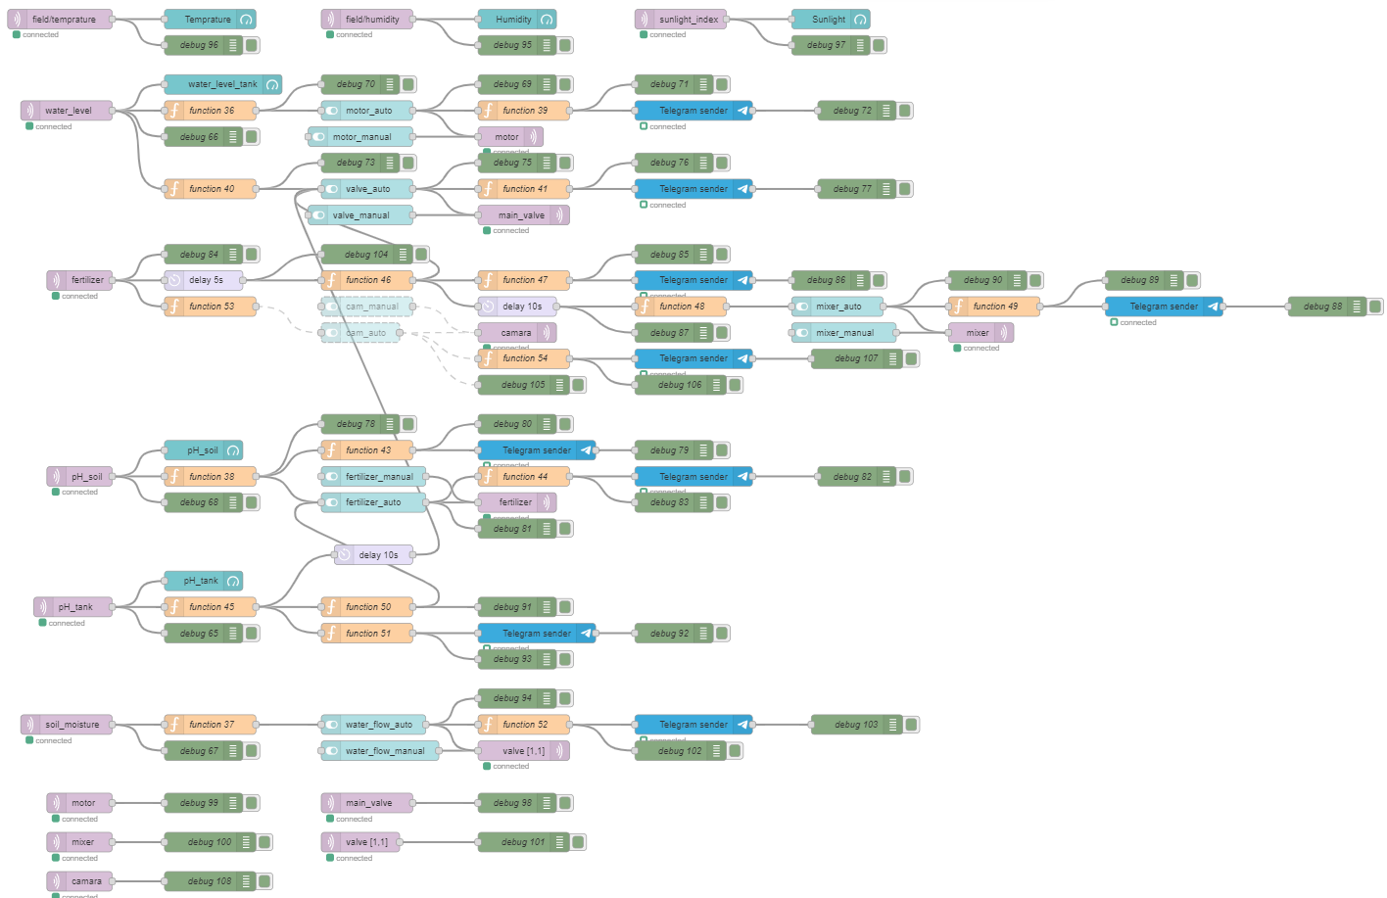

Figure 1: Developed system in Node-Red

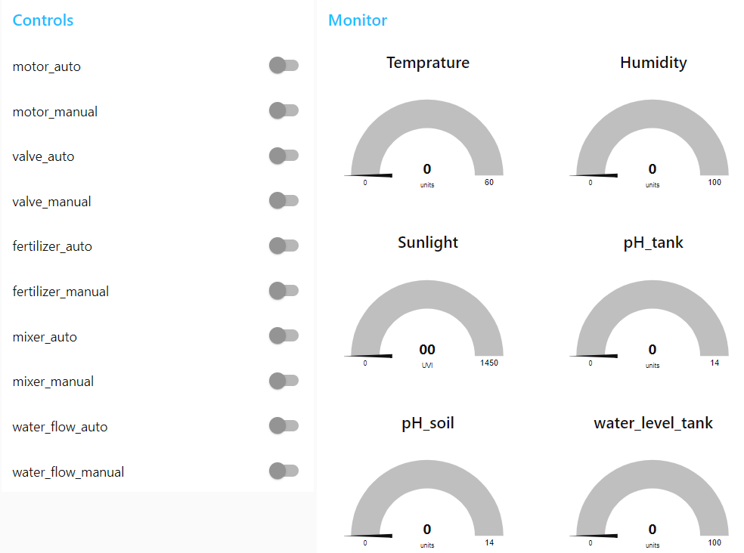

Figure 2: User Interface for Controlling and Monitoring

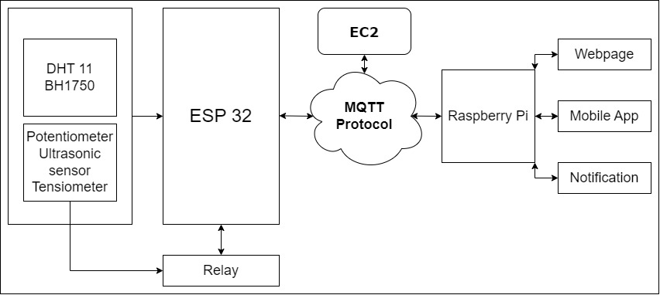

Figure 3: System Architecture

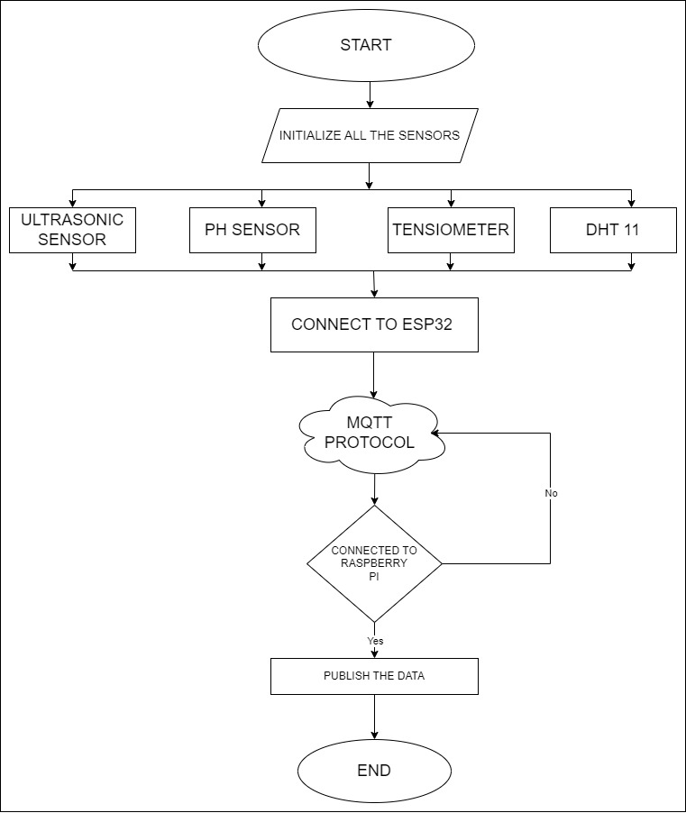

Figure 4: Flow diagram for sensor connection

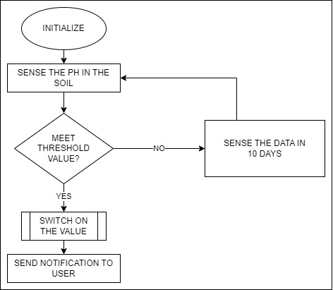

Figure 5: Flow diagram for pH sensor in soil

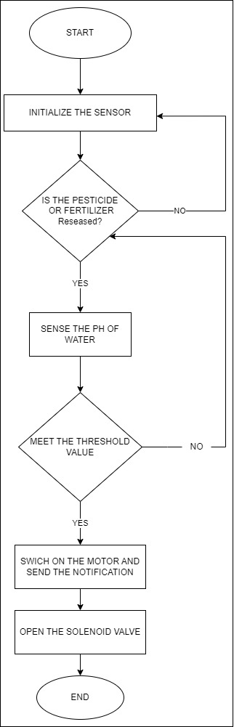

Figure 6: Flow diagram for pH sensor in Water Tank

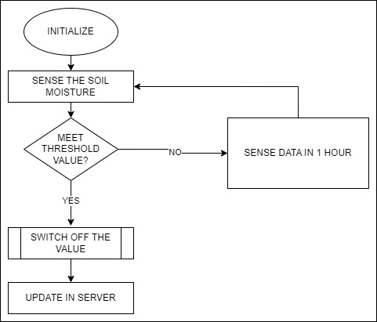

Figure 7: Flow diagram for Soil Moisture sensor

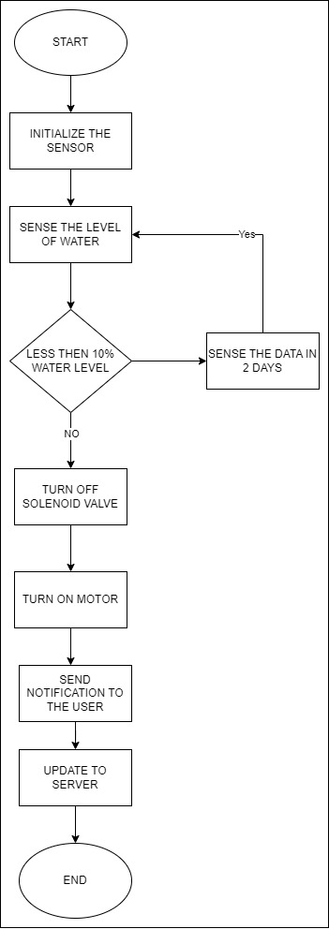

Figure 8: Flow diagram for Relay module for Water motor switching

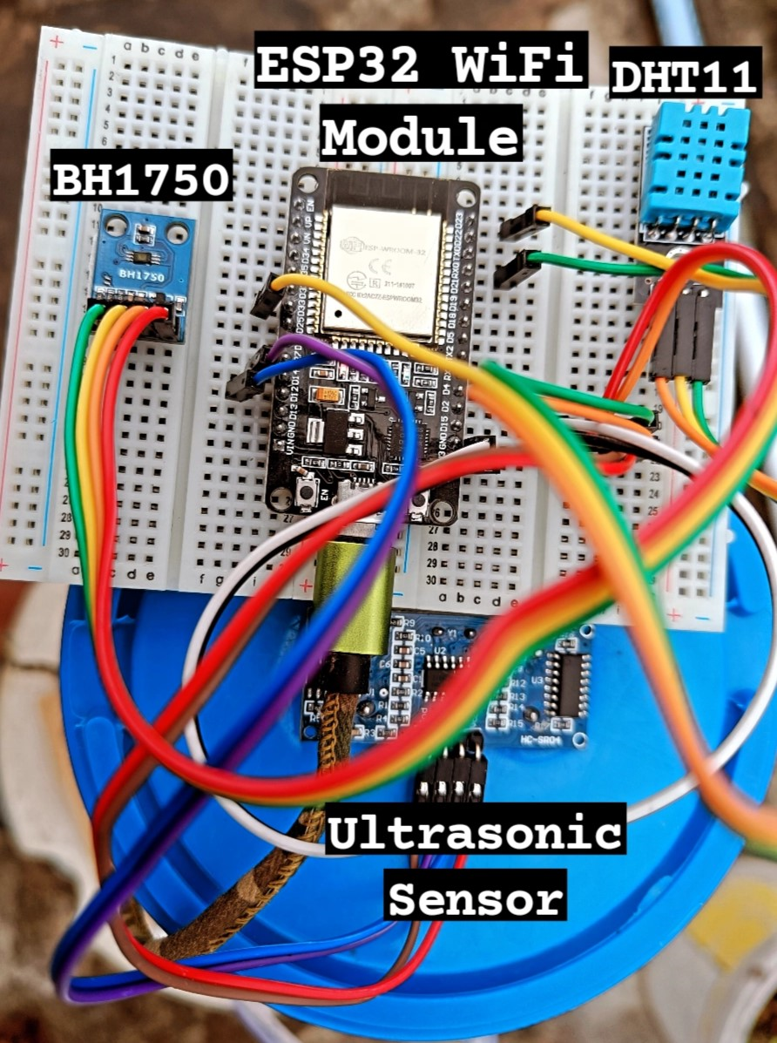

Fig 9: DHT11, BH1750 and Ultrasonic Sensor (s) integrated to ESP32 WiFi Module 1

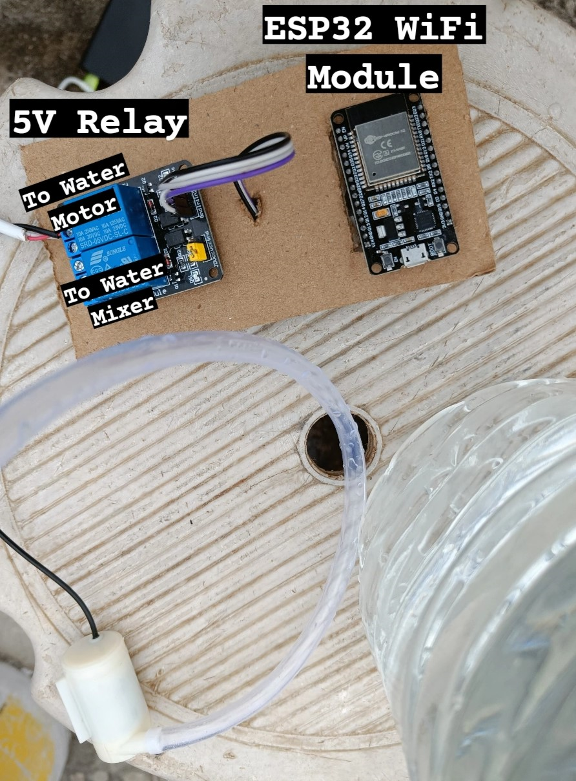

Fig 10: Relay Module 1 connected to ESP32 WiFi Module 2

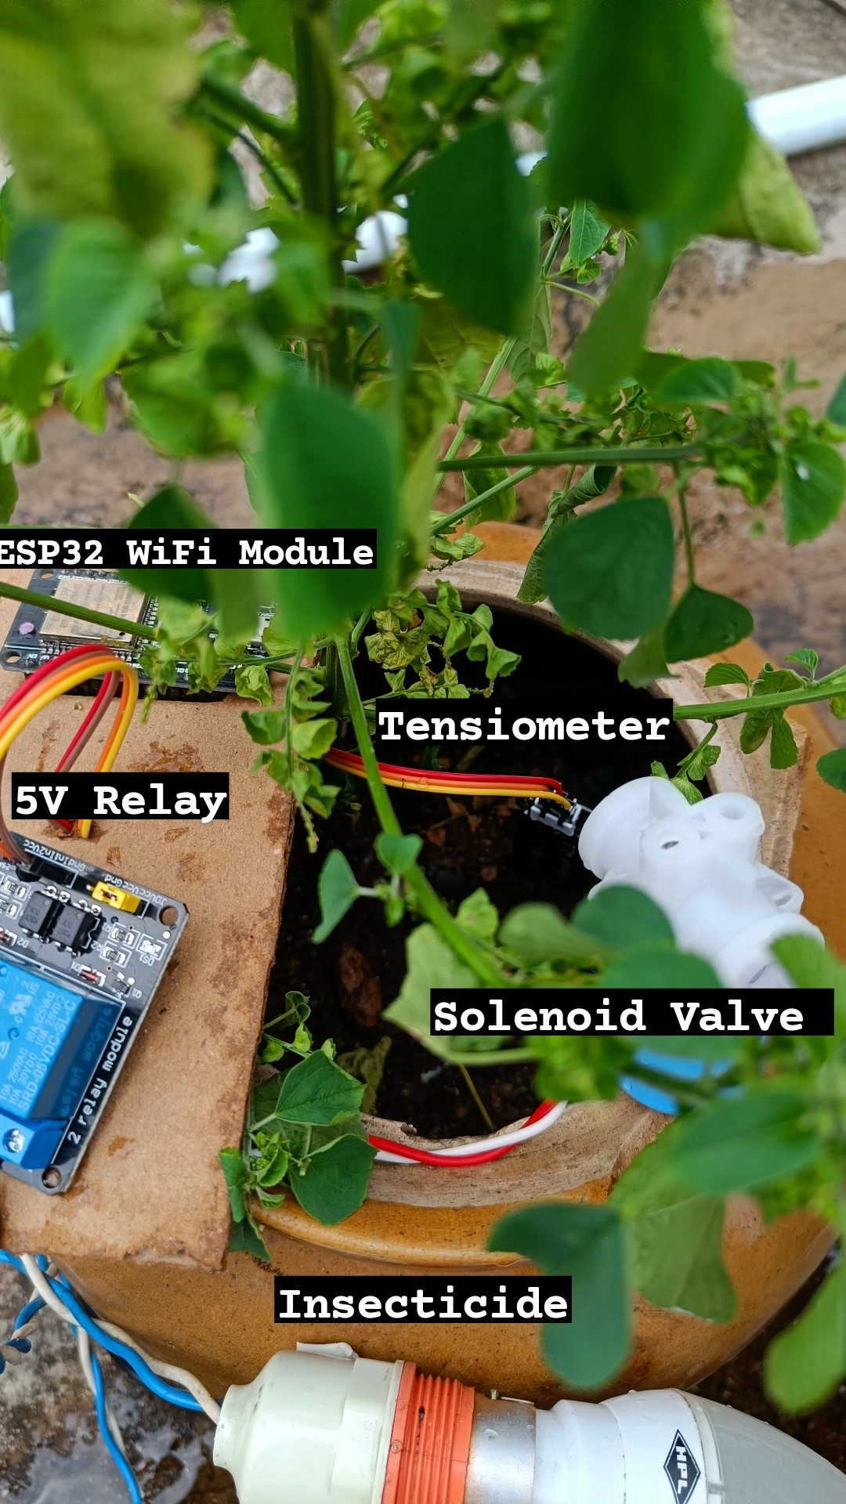

Fig 11: Top view of ESP32 WiFi Module 3 connected to Tensiometer and to Relay Module 2

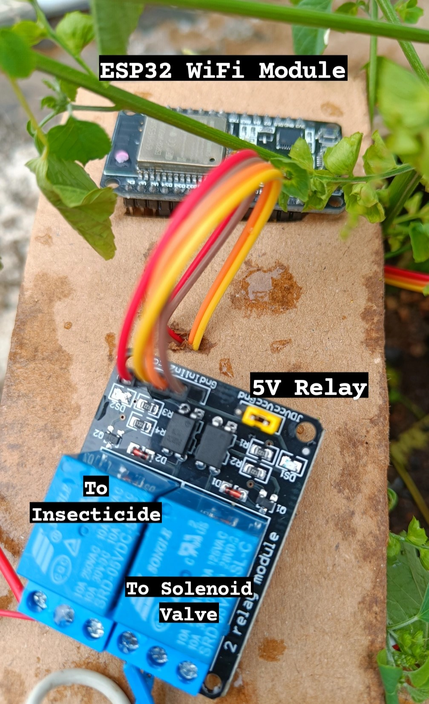

Fig 12: ESP32 WiFi Module 3 connected to Relay Module 2 that controls Insecticide and Solenoid Valve

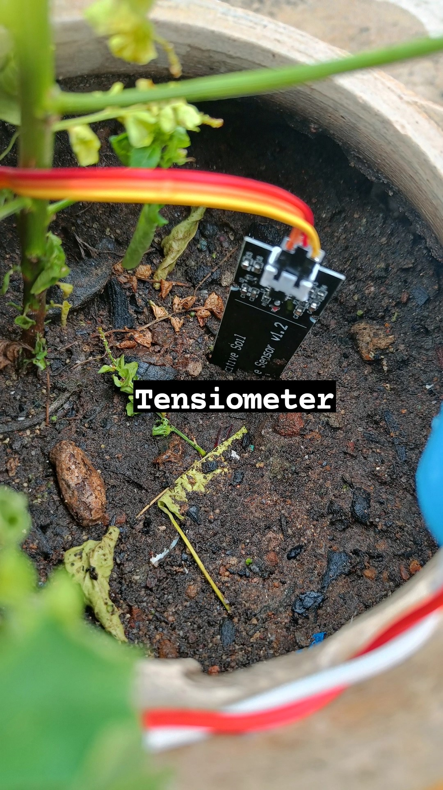

Fig 13: Tensiometer integrated to ESP32 WiFi Module

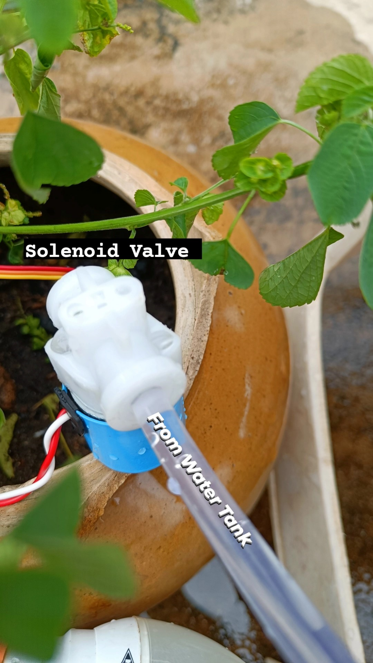

Fig 14: Solenoid Valve Integrated to control Flow of Water to Plant